Sample Median – middle# or avg of two midlle#s

Z is a standard normal random variable

P(0≤Z≤2.17)=φ(2.17)-φ(0)=.9850-.5000

P(0≤Z≤1)=φ(1)-φ(0)=.8413-.5000

P(-2.50≤Z≤0)=φ(0)-[1-φ(2.50)]

=.5000-[1-.9938]

P(-2.50≤Z≤2.50)=φ(2.50)-[1-φ(2.50)]

=.9938-(1-.9938)

P(Z≤1.37)=.9147

P(-1.75≤Z)=1-[1-φ(1.75)]=.9599

P(1.50≤Z)=1-φ(1.50)=.0668

P(|Z|≤2.50)

= P(-2.50≤Z≤2.50)=φ(2.50)-[1-φ(2.50)]

=.9938-(1-.9938)

Box with 4x40w, 5x60w, 6x75w

Choose 3

Prob of exactly two 75w

(6) (9)

(2) (1)

(15)

(3)

Prob all have same rating

(4)**+**(5**)+**(6)

(3) (3) (3)

(15)

(3)

Probability one of each selected

(4) (5) (6)

(1) (1) (1)

(15)

(3)

Select one at a time until 75w

is found

Probability it is the sixth

(first 5 are 60 or 40)

(9)

(5)

(15)

(3)

Mean→ x =(x1+…xn)/n

-

x

Sample Variance→ s2 = [∑(xi - )2]/n-1 = SXX/n-1

Sample Standard Variance→ s=√(s2)

P(AΠB) = P(A)P(B)

P(A U B) = P(A) + P(B) – P(A Π B)

U

U

U

U

U

P(AUBUC) = P(A) + P(B) + P(B) – P(A B) – P(A C) – P(B C) + P(A B C)

Permutations Pk,n= n!/(n-k)! where n is the group size and k is the subset size

n

k

Combinations Ck,n=( ) [“n choose k”] = Pk,n/k! = n!/[k!(n-k)!]

φ(c)=.9838->c=2.14

P(0≤Z≤c)=.291->φ(c )-.5=.291->

φ(c)=.791->c=.81

P(c≤Z)=.121->1-φ(c )=.121->φ(c )=.879 ->c=1.17

P(-c≤Z≤c)=.668->φ(c)-[1-φ(c)]

=2φ(c)-1=.668->φ(c)=.834->.c=.97

P(c≤|Z|)=1-(P|Z|<c)=1-[φ(c)-φ(-c)]=

1-[2φ(c)-1]=2-2φ(c)=.016->φ(c)=.992

->c=2.41

P(A|B) is the conditional prob of A given that event B occurred

U

P(A|B)= P(A B)

P(B)

Quadratic –b+/-√(b2-4ac)

2a

Mean Value E(X)=np where n is sample size and p is percentage of sample

P(A)=.75 P(B|A)=.9 P(B|A’)=.8

P(C|AΠB)=.8 P(C|AΠB’)=.6

P(C|A’ΠB)=.7 P(C|A’ΠB’)=.3

Tree Diagram

P(AΠBΠC)=(.75)(.9)(.8)

P(BΠC)=P(AΠBΠC)+P(A’ΠBΠC)

=(.75)(.9)(.8)+(.25)(.8)(.7)

P(C)= P(AΠBΠC)+P(A’ΠBΠC)+ P(AΠB’ΠC)+P(A’ΠB’ΠC)

P(A|BΠC)=P(AΠBΠC)/P(BΠC)

Standard Deviation SD(X)=√(np(1-p)

30% want new,70% want used

Consider 25 purchasers

X~Bin(n=25,p=.3)

Mean Value = E(x)=np=25(.3)=7.5

Std Dev=SD(X)=√(np(1-p)) =√(25)(.3)(.7)=2.29

Prob that the # who want new is more than 2 SD from the mean value

7.5+/-2(2.29)=2.92&12.08

X<2.92 or X>12.08

P(X<2.92 or X>12.08)

=1-P(2.92≤X≤12.08)

=1-P(3≤X≤12)

12

=1-∑(25)(.3)x(.7)25-x=1-.9736

x=3( x )

Two component system

2nd comp works P(B)=.9

At least one works P(AUB)=.96

Both work P(AΠB)=.75

If the first works, what is the prob the second works, P(B|A)?

P(AUB)=P(A)+P(B)-P(AΠB)

P(B|A)=P(BΠA)/P(A)

PMF ->b(x;n,p) = (n)px(1-p)n-x for x=0,1…n

Normal distribution mean value μ=96

Standard deviation σ=14

Probability value exceeds 100

P(X>100)=1-φ[(100-96)/14)]=1-φ.29

=1-.6141=.3859

Probability between 50 and 80

P(50<X<80)

=φ[(80-96)/14)]-φ[(50-96)/14)]

=[1-φ(1.5)]-[1-φ(3.29)]=.1266

(x)

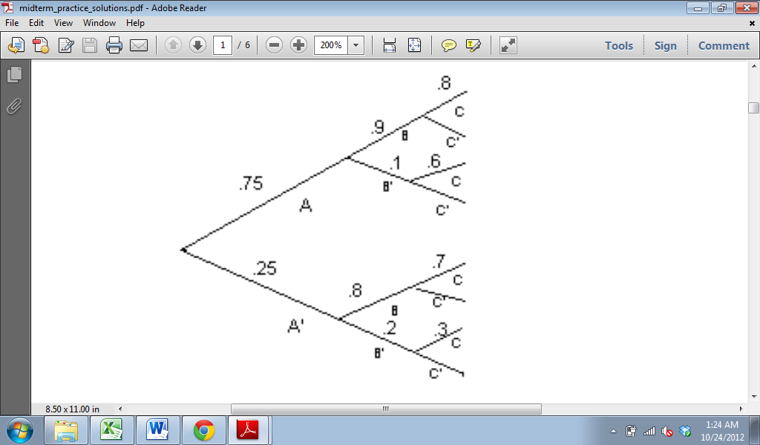

For X~Bin(n,p),cdf isB(x;n,p)

For nb(x;r,p)

E(X)=r(1-p) V(X)=σ2 = r(1-p)=np(1-p)

P p2

Poisson distribution

Reaction time is a continuous random variable with pdf

3 ▪ 1 1≤x≤3

f(x)= 2 x2

1. otherwise

Obtain the cdf

x

∫13/2 ▪1/y2 dy = 3/2[1-(1/x)]

Prob that reaction time is at most 2.5

P(X≤2.5)=F(2.5)=3/2[1-(1/2.5)]=.9

Prob reaction time is b/w 1.5 and 2.5

P(1.5≤X≤2.5)=F(2.5)-F(1.5)=.4

Expected reaction time = E(X)

3  3

∫1 x ▪3/2 ▪ 1/x2 dx = 3/2∫11/x dx

=1.5 (ln 3 – ln 1)=1.648

Standard deviation of reaction time

3 3

E(X2)= ∫1 x2 ▪3/2 ▪ 1/x2 dx = 3/2∫1dx=3

V(X)=E(X2)-[E(X)]2=3-1.6482=.284

SD = √V(X) =√.284

b(x;n,p) -> P(x;μ)=e-μ▪μx

x!

X has Poisson distribution with μ=4

Use table

P(X≤4)=F(4;4)=.629

P(X<4)=P(X≤3)=F(3;4)=.434

P(4≤X≤8)=F(8;4)-F(3;4)=.545

P(8≤X)=1-P(X<8)=1-P(X≤7)=1-F(7;4)=.51

What is prob that X exceed MV(σ) by no more than one SD

μ=4 σ=√4=2

P(X≤μ+σ)=P(X≤6)=F(6;4)=.889

μ=np

75% purch certain type A

Number of next purchases X=15

Pmf of X is b(x;15,.75)

P(X>10)=1-P(X≤10)=1-B(10;15,.75)

=1-.314=.686

P(6≤X≤10)=B(10;15,.75)-B(5;15,.75)

=.314-.001=.31

μ=(15)(.75)=11.75, σ2=(15)(.75)(.25)

10 of A in stock and 8 of B in stock

Prob that the 15 requests are met

X≤10 and 15-X≤8->7≤X≤10

P(7≤X≤10)=B(10;15,.75)-B(6;15,.75)=.310

probability distribution -> pdf -> P(a≤X≤b)=∫ba f(x)dx

uniform distribution f(x;A,B)=1/(B-A) for A≤X≤B

cumulative distribution -> cdf -> F(x)=P(X≤x)=∫b-∞ f(y)dy

expected/mean value = μx=E(X)=∫∞-∞ x ▪ f(x)dx

variance of continuous random variable X with pdf f(x) and mean value μ is:

σ2x=V(X)=∫∞-∞ (x-μ)2 ▪ f(x)dx = E[(X-μ)2]

SD of X is σX=√V(X)

V(X)=E(X2)-[E(X)]2

If X has a normal distribution with mean μ and SD σ the Z= (X-μ)/σ

P(a≤X≤b)=φ[(b-μ)/σ] - φ[(a-μ)/σ]

P(X≤A)= φ[(a-μ)/σ] P(X≥b)=1- φ[(b-μ)/σ]

P(X≤x)=B(x,n,p)=φ[(x+.5-np)/(√(npq))]

Exponential distribution

F(x;λ)=λe-λx for x≥0

E(X+Y)=∑(x+y)▪p(x,y)=E(X)+E(Y)

E(X)=(x1▪(∑(x,y))+(x2▪(x,y))…(xn▪(x,y))